BRAND GUIDELINES
The Next Chance Collaborative · Visual Identity v1.0
────────────────────────────────────────────────────────────
Logo
Our mark is three nested chevrons, advancing forward together. They symbolize a coalition — multiple organizations, the same direction. The chevron is bold, geometric, and unmistakably forward-leaning.

Primary horizontal lockup. Use this whenever space allows.
Other lockups
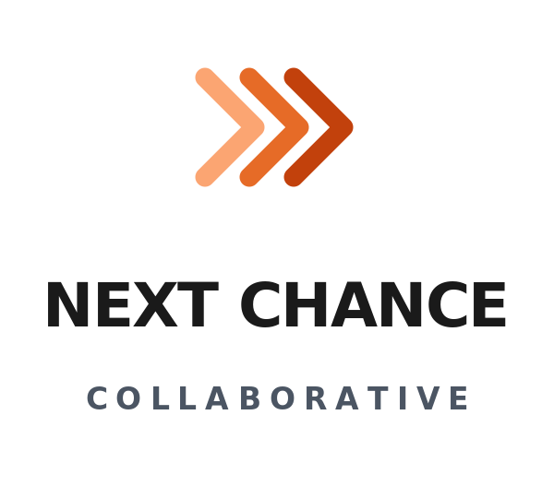  Stacked lockup  Use for square / vertical space |   Mark only  Use for favicons, social avatars
Logo do's and don'ts
- DO use the logo with adequate clear space — at least the width of one chevron on every side.
- DO use the logo on white, cream, or a light orange background. On dark backgrounds, use a white-out version.
- DO use the monochrome version (logo-mono.svg) where color isn't possible.
- DON'T stretch, rotate, or distort the chevrons.
- DON'T change the colors of the chevrons — the gradient is intentional.
- DON'T add drop shadows, outlines, or other effects to the mark.
- DON'T place the logo on busy photographic backgrounds without a solid white card behind it.
Color Palette
Two colors do most of the work: deep orange (warmth, energy, hope) and charcoal (gravity, seriousness). Cream and slate gray support.
 | Primary Orange  #C2410C · rgb(194, 65, 12) | Logo, primary buttons, headlines, links
 | Light Orange  #FBA572 · rgb(251, 165, 114) | Background lightest chevron, soft accents
 | Mid Orange  #E66B27 · rgb(230, 107, 39) | Mid chevron, hover states
 | Dark Orange  #9A3412 · rgb(154, 52, 18) | Button hover, deep contrast
 | Cream  #FFF7ED · rgb(255, 247, 237) | Hero background, warm sections
 | Charcoal  #1A1A1A · rgb(26, 26, 26) | Body text, headlines
 | Slate Gray  #4B5563 · rgb(75, 85, 99) | Secondary text, captions
 | Border Gray  #E5E5E7 · rgb(229, 229, 231) | Dividers, card borders
Typography
Single sans-serif family. Bold for headlines, regular for body, light/tracked for support text. We use system fonts so the brand renders consistently anywhere.
Display / Headlines | System sans-serif heavy  Inter Black, Helvetica Neue Bold, Arial Black  Letter-spacing: -0.02em on large sizes
Body | System sans-serif regular  Inter, Helvetica Neue, Arial  Line-height: 1.55
Eyebrows / Labels | System sans-serif bold caps  Tracked +0.08em  Always uppercase, always orange
Captions / Meta | System sans-serif small  Slate gray, ~12px / 9pt  Below normal text
Voice & Tone
Four principles guide every word we publish.
1. Plain, declarative, confident
Short sentences. Active verbs. We're not shy about what we believe or what we ask for. Avoid jargon — both nonprofit-speak and ministry-speak.
2. Hospitable to both faith and secular
We name the faith roots without making them a barrier. We use language that lets a Catholic bishop, a returning citizen, a secular policy researcher, and an evangelical pastor all feel addressed.
3. Always credit returning citizens
They are not a population to be served. They are colleagues, members, leaders. Default to 'returning citizens' or specific people's names — never 'inmates,' 'offenders,' or 'ex-cons.'
4. Hopeful but not naive
We don't sugarcoat what reentry costs or how often it fails. We don't perform sentimentality. The work is hard; we describe it as hard. Hope shows up in what we do, not in our adjectives.
Approved Taglines
- "No one walks out of a prison gate alone." — primary tagline; for hero, footer, business cards
- "Stitching the handoffs every returning citizen needs." — secondary; for funder pitches, partnership decks
- "Help people leave prison and stay out." — blunt utility line; for recruitment ads
Language: Do / Don't
Do say | Don't say
✓ Returning citizen | ✗ Inmate, ex-con, offender, felon
✓ Person who has been incarcerated | ✗ Convict
✓ Reentry | ✗ Released back into society
✓ Coalition member | ✗ Stakeholder, partner organization
✓ Walk alongside | ✗ Mentor (when about peer support)
✓ Coordinate handoffs | ✗ Wraparound services
Logo Files
Found in your workspace folder:
- logo-horizontal.svg — Primary horizontal lockup
- logo-stacked.svg — Stacked vertical lockup (for square spaces)
- logo-mark.svg — Mark only (favicons, social avatars)
- logo-mono.svg — Monochrome (B&W contexts)
To export to PNG/JPG at any resolution, open the SVG in any browser and screenshot, or use any free SVG-to-PNG converter online. SVGs scale to any size without quality loss.
────────────────────────────────────────────────────────────
Brand questions: gdoepel@gmail.com · v1.0 · May 2026

